Math Quiz #1 – Study Guide

I should know how to….

1) Write numbers in standard form

2) Write numbers in expanded form

3) Write numbers in a place value chart

4) Write numbers in words

5) Determine that place value of a digit in a larger number
For example: 876 250 = ten thousands

6) Understand and sort data from a chart (determine largest number, smallest number, writing numbers in words etc.)

7) Understand the number 1 million

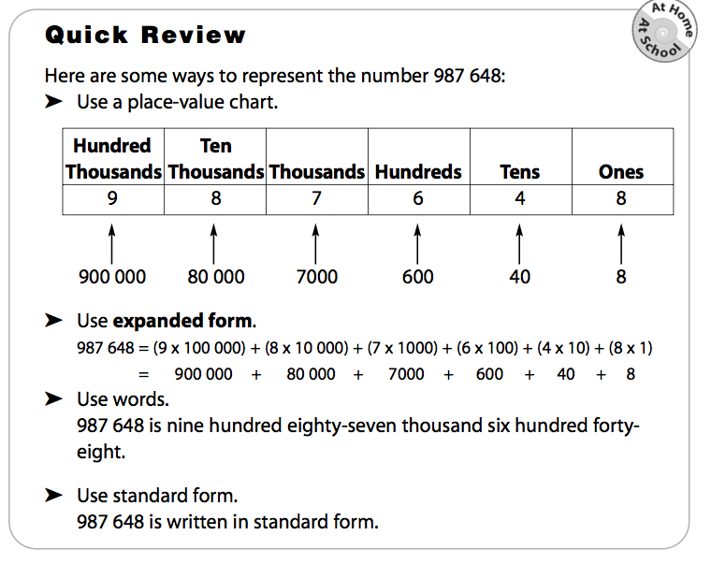
8) Understand and be able to figure out how many 10s, 1 000s, 5 000s etc are in 1 000 000

Practice Questions Name: _____________ # _______

1) Write the following numbers in standard form

- three hundred thousand eight hundred twenty-three

- nine hundred thirty five thousand seven hundred twelve

- two hundred forty seven thousand six hundred fifty-five

2) Write the following numbers in expanded form

- 856 990

- 562 128

- 268 335

3) Write the following numbers in words

- 367 110

- 786 540

- 135 246

4) Write each number in standard form.

a) 30 000 + 500 + 80 + 4

b) 200 000 + 40 000 + 70

c) 800 000 + 20 000 + 5000 + 400 + 1

d) 500 000 + 3000 + 700

5) Place the following numbers on a place value chart
- 476 689
- 986 521
- 557 349

6) There are 100 pennies in one roll. How many pennies are there in

- 5 rolls? b) 10 rolls?

c) 50 rolls? d) 100 rolls?

e) 500 rolls f) 1000 rolls?

7) How many days would it take you to spend $1 000 000 if each day you spend:

- $100 000? b) $50 000?

c) $10 000? d) $1 000?

e) $100? f) $5 000?

8) A charity collected 10 000 ten dollar bills. How much did they collect?

9) .Suppose there are 10 trading cards in each package?
a) How many packages would you need to package 800 cards?

b) How many packages would you need to package 8000 cards?

